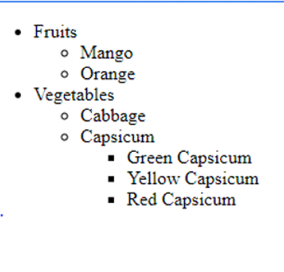
HTml Code

<!DOCTYPE html>
<html lang="en">
<head>
<meta charset="UTF-8">
<meta name="viewport" content="width=device-width, initial-scale=1.0">
<title>Fruits and Vegetables List</title>
<style>
/* Optional CSS for styling the box */
.box {
border: 2px solid blue;
padding: 10px;
width: fit-content;
}
</style>
</head>
<body>

<div class="box">
<ul>
<li>Fruits
<ul>
<li>Mango</li>
<li>Orange</li>
</ul>
</li>
<li>Vegetables
<ul>
<li>Cabbage</li>
<li>Capsicum
<ul>
<li>Green Capsicum</li>
<li>Yellow Capsicum</li>
<li>Red Capsicum</li>
</ul>
</li>
</ul>
</li>
</ul>
</div>

</body>
</html>

